**HUMAN ACTIVITY RECOGNITION**

**A Project Report Submitted by:-**

Jani Kush (170770107054)

Doshi Rahil (170770107041)

Dave Sanket (170770107032)

Joshi Keval (170770107060)

Shah Tapan (170770107217)

Kedia Aryan (170770107004)

***In fulfillment for the award of the degree of***

**Bachelor in Engineering**

**In**

**Computer- Engineering**



**Internal faculty Guide:**

**Prof. Mayuresh Kulkarni**

**SILVER OAK COLLEGE OF ENGINEERING AND TECHNOLOGY**

**OPP. BHAGWAT VIDHYAPITH , NEAR GOTA CROSS ROAD,**

**AHMEDABAD-382481**

**Candidate’s Declaration**

We have finished our project report entitled “Human Activity Recognition” and submitted to our respective guide. We are in the 7th semester and we have tried to give our best. We have done our work honestly and in a good way.

We further declare that to the best of our knowledge the report of C.E. 7th semester.

**First** candidate’s name : **Jani Kush**

Branch : **CE**

Enrollment Number : **170770107054**

**Second** candidate’s name :  **Doshi Rahil**

Branch : **CE**

Enrollment Number : **170770107041**

**Third** candidate’s name : **Dave Sanket**

Branch : **CE**

Enrollment Number : **170770107032**

**Fourth** candidate’s name : **Joshi Keval**

Branch : **CE**

Enrollment Number : **170770107060**

**Fifth** candidate’s name : **Shah Tapan**

Branch : **CE**

Enrollment Number : **1707701070217**

**Sixth** candidate’s name : **Kedia Aryan**

Branch : **CE**

Enrollment Number : **170770107004**

Submitted to:

**Silver Oak College Of Engineering & Technology.**

**Abstract**

Human Activity Recognition is a project about developing a system that constantly monitors and analyzes footage of security cameras that are commonly pre-installed at all the stores. Secondly, it checks for any suspicious activities and also keeps on analyzing the behavior of each customer. If any suspicious activity is detected, the software instantly recognizes and reports to the supervisor, who can review the footage, and act on it.

The primary objective of human activity recognition is the prevention of potential theft; to prevent any type of confusion the target is approached and asked if they need help, which leads to a good chance that the theft never happens.

The secondary objective is the opportunity, it’s huge! As the retailers become more open to embracing technology to meet consumer needs, as well as improve bottom lines. This technology can prevent losses to a certain point. Also, this technology will prevent internal frauds.

**Acknowledgment**

In the present world of competition there is a race of existence in which those are having will to come forward succeed. Project is like a bridge between theoretical and practical working. With this truth we joined this particular project.

We would like to extend our heartily thanks with a deep sense of gratitude and respect to all those who has provided us immense help and guidance during our project. We would like to express our sincere thanks to our faculty guide **Prof. Mayuresh Kulkarni** for providing a vision about the system and for giving us an opportunity to undertake such a great challenging and innovative work. We are grateful for the guidance, encouragement, understanding and insightful support given in the development process.

We would like to extend our gratitude to **Dr. Satvik Khara,** Head of Department Computer Engineering, Silver Oak College of Engineering and Technology, Ahmedabad, for his continuous encouragement and motivation.

Last but not the least we would like to mention here that we are greatly indebted to each and everybody who has been associated with our project at any stage but whose name does not find a place in this acknowledgement.

**INDEX**

**Chapter no. Title Pageno.**

1. **Introduction** 9

* 1. **Project Summary** 9
  2. **Project Scope** 9
  3. **Objective** 9
  4. **Technologies and Literature Review** 10

1. **Software Project Management** 10

**2.1 Project Planning and Scheduling** 10

2.1.1 Project Planning 10

2.1.2 Project scheduling 10

**2.2 Project Development Approach** 11

**2.3 Project Plan** 12

2.3.1 Milestone and Deliverables 12

**3. System Requirement Study** 16

**3.1 User Characteristics** 16

**3.2 Hardware and Software Characteristics** 16

**3.3 Constraints** 17

3.3.1 Regulatory Policies 17

3.3.2 Hardware Limitation 17

**4. System Analysis** 18

**4.1 Study of Current System** 18

**4.2 Requirement of this System** 18

4.2.1 Functional Requirement 18

4.2.2 Non-Functional Requirement 18

**4.3 Feasibility Study** 20

**4.4 Requirement Validation** 21

**4.5 Function of the System** 21

4.5.1 Use case 22

4.5.2 Activity Diagram 23

4.5.3 Sequence Diagram 23

**4.6 Data Modeling** 25

4.5.1 ER diagram 25

4.5.2 Class Diagram 26

**5. System Design** 28

**5.1 System procedural design** 28

5.1.1 Design pseudo code or algorithm for 28

method of operation

5.1.2 Flow Chart Diagram 29

**5.2 Data modeling** 30

5.2.1 State Transition diagram 30

**6. Implementation Planning and Details**

**6.1 Implementation Environment**

(Single user vs. Mutli-user , GUI vs. Non GUI) 31

**6.2 Program/Modules Specification** 31

**6.3 Security Features** 32

**6.4 Coding Standards** 33

**6.5 Sample Coding** 34

**7. Testing(choose appropriate testing strategy or techniques suitable to your system)**

**7.1 Testing Plan** 35

**7.2 Testing Strategy** 36

**7.3 Testing Methods** 37

**7.4 Test Cases (Purposes, Rquired output, Expected Result)** 40

**CHAPTER-1**

**INTRODUCTION**

* 1. **Project Summary**
* In this project we are going to develop the website based on Artificial Intelligence, Machine Learning, Computer Vision, Flutter, Python, Html, Css, Javascript.
* Here, the project gives the view of the suscpicious activity which are held in the general stores, malls, banks, jewllery shops, etc.
* So here we are going to develop a system that constantly monitors and analyzes footage of security cameras that are commonly pre-installed at all the stores.
  1. **Project Scope**
* The project scope over here is to establish how one can be standstill to the potential of moving ahead for the robbery.
* In this when AI, ML and open CV is used for the smart management of the suscpicious activity.
* Many different activities can be overwhelmed in the project so there are many scope.
* The scope of this is software is :- also used in many different department, governmental places etc.
  1. **Objective**
* The primary objective of human activity recognition is the prevention of potential theft; to prevent any type of confusion the target is approached and asked if they need help, which leads to a good chance that the theft never happens.
* The secondary objective is the opportunity, it’s huge! As the retailers become more open to embracing technology to meet consumer needs, as well as improve bottom lines. This technology can prevent losses to a certain point. Also, this technology will prevent internal frauds.
  1. **Technology and Literature Review**
* The front-end used in our project is HTML, CSS, Bootstrap, Javascript, and in back-end python, flutter, AI, ML, Computer Vision.
* **HTML**

HTML an initialize of Hyper Text Markup Language for web pages.

It provides a means to describe the structure of text based information in document by denoting text as headings, paragraphs, lists and so on and to supplement that text with interactive forms, embedded images and other objects.

* **Javascript**

JavaScript supports the development of both client and server components of web based applications.

On the client side, it can be used to write programs that are executed by a web browser within the context of the web page.

On the server side, it can be used to write web server programs that can be process information submitted by a web browser and then update the web browser display accordingly.

* **Computer Vision**

Computer vision is a field of [artificial intelligence](https://www.sas.com/en_in/insights/analytics/what-is-artificial-intelligence.html) that trains computers to interpret and understand the visual world. Using digital images from cameras and videos and [deep learning](https://www.sas.com/en_in/insights/analytics/deep-learning.html) models, machines can accurately identify and classify objects.

* **Artificial Intelligence**

Artificial intelligence (AI) refers to the simulation of human intelligence in machines that are programmed to think like humans and mimic their actions. The term may also be applied to any machine that exhibits traits associated with a human mind such as learning and problem-solving.

* **Machine Learning**

Machine learning is an application of artificial intelligence (AI) that provides systems the ability to automatically learn and improve from experience without being explicitly programmed. Machine learning focuses on the development of computer programs that can access data and use it learn for themselves.

* **Flutter**

Flutter is a free and open source Google mobile UI framework that provides a fast and expressive way for developers to build native apps on both IOS and Android. ... Flutter builds from a single codebase, compile directly to the native arm code, Use the GPU and access the platform APIs and services.

* **Python**

Python is a general-purpose coding language—which means that, unlike HTML, CSS, and JavaScript, it can be used for other types of programming and software development besides web development. That includes back end development, software development, data science and writing system scripts among other things.

**CHAPTER -2**

**SOFTWARE PROJECT MANAGEMENT**

* 1. **Project planning and scheduling**
     1. **Project Planning**
        + - Project planning is part of project management, which relates to the use of schedules such as Gantt charts to plan and subsequently report progress within the project environment.
          - Initially, the project scope is defined and the appropriate methods for completing the project are determined. Following this step, the durations for the various tasks necessary to complete the work are listed and grouped into a work breakdown structure.
          - Project planning is usually organized in different areas of a project, including project plans, workloads and the management of teams and individuals.
     2. **Project Scheduling**
        + Project Scheduling is the culmination of a planning activity that is primary component of software project management.
        + When combined with estimation methods and risk analysis, scheduling, establishes a road map for the project management.
        + Scheduling begins with the process composition. The characteristics of the project are used to adapt an appropriate task set for the work to be done.
        + The task network is used to compute the critical project path, a time line chart and a variety of project information.
  2. **Project Development Approach**

The activities we followed for this project is listed below:

* Planning the work or objectives
* Analysis & Design of objectives
* Assessing and controlling risk
* Allocation of resources
* Organizing the work
* Database Designing
* Form Design

The Process Paradigm we used for our project is Incremental Model.

**The Incremental Software Process Model**

* + The Incremental Model combines elements of the linear sequential model with the iterative philosophy of prototyping. The incremental model applies linear sequences in a staged fashion as calendar time progresses.
  + Each linear sequence produces a deliverable “increment” of the software. For example, word processing software developed using the incremental paradigm might deliver basic file management, editing and document production functions in the first increment; more sophisticated editing and document production capabilities in the second increment; spelling and grammar checking in the third increment; and advanced page layout capability in the fourth increment.
  + The Incremental process model, like prototyping and other evolution approaches, is iterative in nature.
  + Early increments are stripped down versions of the final product, but they do provide capability that serves the user and also provide a platform for evaluation by the user.

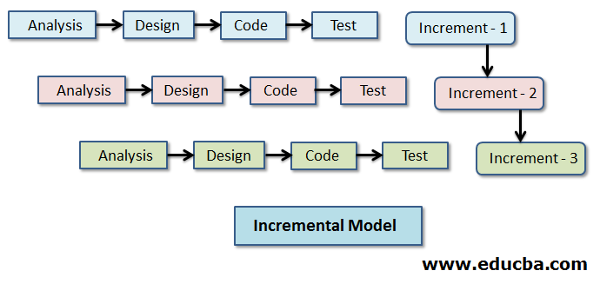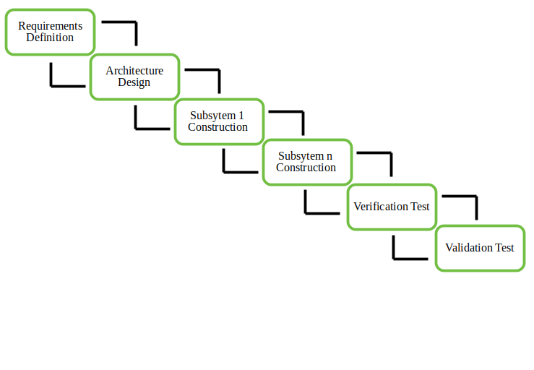

* + 1. **Milestone and Deliverables**
       - In this project, we went through Module Wise Completion. First we did analysis of first module; we went through all the requirements for first module that is Admin Module.
       - By this analysis we decided field of all the tables of Admin Module. Then we started Database Design.
       - After competing it we started with the design of all forms of this module. Then we did coding and finally validations and testing of forms that we made.
       - There was continuously interaction with the client that was very beneficial for us.
       - When we completed whole project we started testing the whole project for final verification.
       - Then we started documentation of our project. Finally, we completed the project with client’s satisfaction.



**CHAPTER -3**

**SYSTEM REQUIREMENT STUDY**

* 1. **SYSTEM REQUIRMENT STUDY**
  2. **User Characteristics:**
     + It describes the type of user which deals with the applications. Basically, this application has three types of users as given below:

1. Administrator
2. Vender
3. User
4. **Administrator:**
   * Responsibility of administrator is to manage the application database and update the data in database regularly. For e.g. manage the data of public.
5. **Vendor:**
   * Responsibility of vendor is to complete tasks which are assigned to him by administrators and manage some part of database.
6. **User**
   * Once the portal being tested and being uploaded then after public (or end user) will use this detector. User in the main reason for which this application is being built. The end user can easily interact with the government using this portal.
   1. **Hardware and Software Characteristics:**

* **Hardware Requirements:**
* Minimum 2.27Ghz processor
* RAM: 2GB minimum
* **Software Requirements:**
* Java Compatible System
* Computer Vision
* Python
* Stable OS
* Tensorflow
  1. **Constraints:**
     1. **Regulatory Policies:**
* Regulatory Policies or mandates, limit the discretion of individual and agencies, or otherwise compel certain types of behavior.
* These policies are generally thought to be best applied when good behavior can be easily defined and bad behavior can be easily regulated and punished through fine and sanctions.
  + 1. **Hardware Limitation**
* The smooth functionality of the portal mainly depends on the speed of hardware and then on speed of the internet. It is always advisable to be update as far as hardware is concerned. The hardware limitation occurs if the user is still using a very low MHz processor or a RAM or less than 128Mb.This will generally reduce the portal and also the use will waste a lot of useful time, energy and resource.

**CHAPTER-4**

**SYSTEM ANALYSIS**

* 1. **Study of Current System**
     + Currently that isn’t any detector that makes governments task easy by adding interactivity and administrative features on the portal.
  2. **Requirement of this System:**
     + We are developing Human Activity Recognition. By using this portal, the government’s task becomes easy and they can complete their task of identifying the public in very efficient manner.
     + Currently, this type of concept is not available in market. We are developing our portal on this creative concept.
     + Analyzing the current scenario, government and private organizations want to make sure that everyone working or visiting a public or private place can be secured by using this type of system.
     1. **Functional Requirement:**

**User Requirement:**

* + - * User who uses this detector should know how to operate it. Because the software has the same look and features like whole software is menu driven.
      * Just click and corresponding thin from menu of hyperlink will be opened.

**Identification of functional requirement:**

* + - * The high-level functional requirement often needs to be identified from an informal problem description document or from a conceptual understanding of the problem.
      * Each high-level requirement characterizes away of system usage by some users to perform some meaningful piece of work.

**Documentation of functional requirement:**

For documenting the functional requirement, we need to specify the set of functionalities supported by the system.

* + - * A function can be identified the state at which the data to input to the system, its input data domain, the output data domain, and the type of possessing to be carried out on the input data to obtain the output data.
    1. **Non functional requirement:**
* Location of Faces, annotated by a shape i.e., square Face Orientation, includes front, left, left-front, right, right-front.etc. Occlusion Degree, defining a face into four regions – eyes, nose, chin, and mouth.
* Location of Eyes, need to mark eye centers.

**Usability:**

* + - * The interface should use terms and concepts, which are drawn from the experience of people who will make most of the system.

**Efficiency:**

* + - * The portal must provide easy and fast access without consuming more cost.

**Readability:**

* + - * User should never be surprised by the behavior of the system and it should also provide meaningful feedback when error occurs so that user can recover from the error.

**Accuracy:**

* + - * The user should require that data are obtained from database and stored in database must be accurate.

**Security:**

* + - * The user wants the data stored in database must be secured and cannot be accessed by unauthorized user.

**Maintainability:**

* + - * User wants that the system should be maintained easily means that if there are some changes required in the system that can be done easily.
  1. **Feasibility Study**
* Feasibility is the measure of how beneficial the development of information system will be to an organization.
* The feasibility analysis is categorized under four different types.

1. Operational Feasibility
2. Technical Feasibility
3. Schedule Feasibility
4. Economic Feasibility
5. **Operational Feasibility:**
   * The System is to be developed for any user who wants to use it. We want our system user friendly and easy to use.
   * The administrator also may be non-technical, so the user interface will be designed in such a way that it gets comfortable for non-technical person to operate easily.
6. **Technical Feasibility:**
   * It is a partially measurement of specific technical solution and the availability of technical resorts and expertise.
   * The analyst must find out whether the current technical resources, which are available in the system is capable of handling the job.
   * If not, then the analyst with the help of developer should confirm whether the technology is available and capable or not.

**Better Considering:**

* + Here we have to consider those tools which are required for developing the project.
  + As far as basic knowledge concerned, we have studied basic of computer vision, python, Tensor-flow, keras.

1. **Schedule Feasibility:**
   * Schedule feasibility corresponds to whether sufficient time is available to complete the project.

**Factor considered:**

* + Schedule of the project
  + Time by which project has to be completed
  + Reporting period

1. **Economic feasibility:**
   * Economic feasibility is a measure of cost effectiveness of a project or solution.
   * For declaring that the system is economically feasible, the benefits from the project should exceed or at least to the equal to the cost of development.
   1. **Requirement Validation:**

* Requirement validation examines this specification to ensure that all the system requirements have been stated unambiguously.
* These inconsistent, error have been detected and corrected and the work products confirmed to the standard.
* Source of the requirement are identified; final Statement of requirement has been examined by original source.
* Requirements related to main requirements are founded.
* Requirements are clarifying stated and are not misinterpreted.
* All sources of requirements are covered to get a maximum requirement.
* All method of finding requirements is applied.
  1. **Function of the System:**
     1. **Use-Case:**
        + In software and systems engineering, a **use case** is a list of steps, typically defining interactions between actor and a system, to achieve a goal.
        + The actor can be a human, an external system, or time.
        + In systems engineering, use cases ae used at a higher level than within software engineering, often representing missions or stakeholder goals.
        + The detailed requirements may then be captured in Systems Modeling Language or as contractual statements.
        + As an important requirement technique, use cases have been widely used in modern software engineering over the last two decades.
        + Use case driven development is a key characteristic of process models and frameworks. With its iterative and evolutionary nature, use case is also a good fit for agile development.
* Use Cases Human Activity Recognition - The system can be used in the following places to identify people:
* Shopping Mall
* Mega stores
* Jewllery shop and many more places were we can detect this kind of suspicious activity.

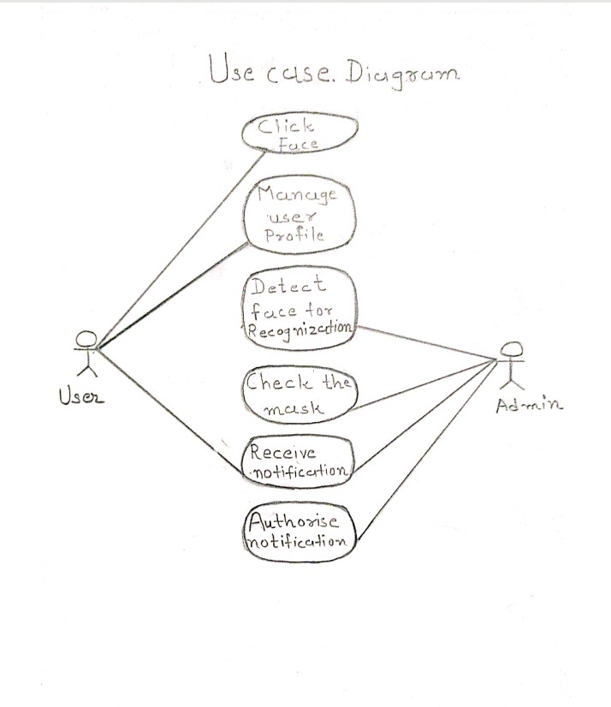

* + 1. **Activity Diagram:**

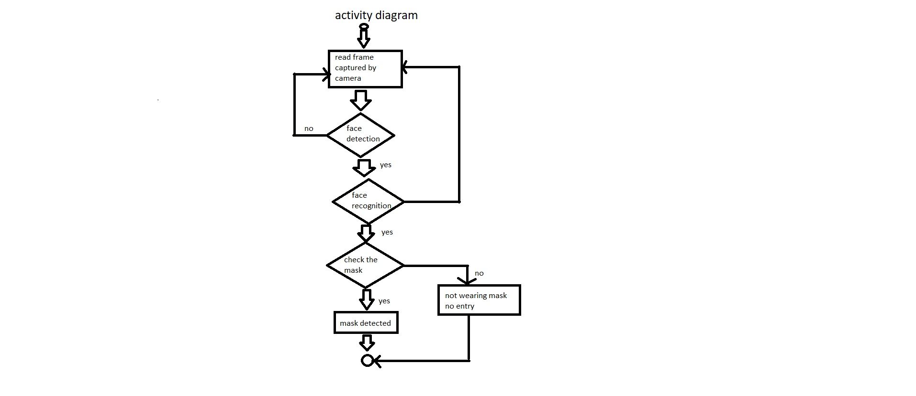

* + 1. **Sequence Diagram:**
       - The well-known [Message Sequence Chart](http://en.wikipedia.org/wiki/Message_Sequence_Chart) technique has been incorporated into the [Unified Modeling Language (UML) diagram](http://en.wikipedia.org/wiki/Unified_Modeling_Language) under the name of **Sequence Diagram**.
       - A sequence diagram shows, as parallel vertical lines, different processes or objects that live simultaneously, and, as horizontal arrows, the messages exchanged between them, in the order in which they occur.
       - This allows the specification of simple runtime scenarios in a graphical manner.
* The well-known [Message Sequence Chart](http://en.wikipedia.org/wiki/Message_Sequence_Chart) technique has been incorporated into the [Unified Modeling Language (UML) diagram](http://en.wikipedia.org/wiki/Unified_Modeling_Language) under the name of **Sequence Diagram**. A sequence diagram shows, as parallel vertical lines, different processes or objects that live simultaneously,

and, as horizontal arrows, the messages exchanged between them, in the order in which they occur. This allows the specification of simple runtime scenarios in a graphical manner.

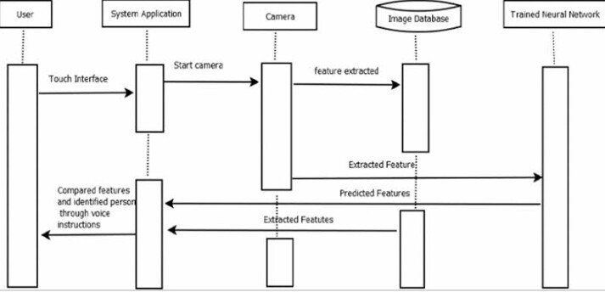

* 1. **Data Modeling:**
     1. **E-R Diagram:**
        + In software engineering, an **entity–relationship model** (**ER model**) is a data model for describing the data or information aspects of a business domain or its process requirements, in an abstract way that lends itself to ultimately being implemented in a database such as a relational database.
        + The main components of ER models are entities and the relationships that can exist among them, and databases.
        + An entity-relationship model is a systematic way of describing and defining a business process.
        + The process is modeled as components (entities) that are linked with each other by relationships that express the dependencies and requirements between them, such as: one building may be divided into zero or more apartments, but one apartment can only be located in one building. Entities may have various properties (attributes) that characterize them.
        + Diagrams created to represent these entities, attributes, and relationships graphically are called entity–relationship diagrams.

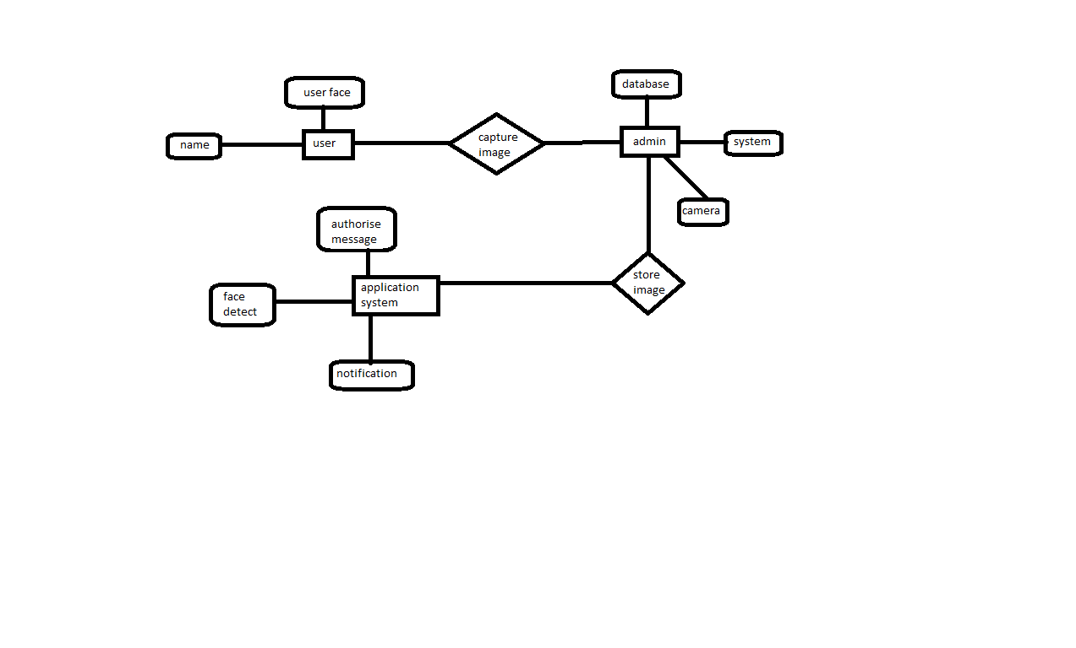

* + 1. **Class Diagram :**
       - In software engineering, a **class diagram** in the Unified Modeling Language (UML) is a type of static structure diagram that describes the structure of a system by showing the system's classes, their attributes, operations (or methods), and the relationships among objects.
       - The class diagram is the main building block of object oriented modeling.
       - It is used both for general conceptual modeling of the systematic of the application, and for detailed modeling translating the models into programming code.
       - Class diagrams can also be used for data modeling.
       - The classes in a class diagram represent both the main objects, interactions in the application and the classes to be programmed.

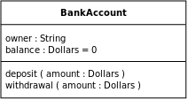

* + - * In the diagram, classes are represented with boxes which contain three parts:
      * The top part contains the name of the class. It is printed in Bold, centered and the first letter capitalized.
      * The middle part contains the attributes of the class. They are left aligned and the first letter is lower case.
      * The bottom part gives the methods or operations the class can take or undertake. They are also left aligned and the first letter is lower case.

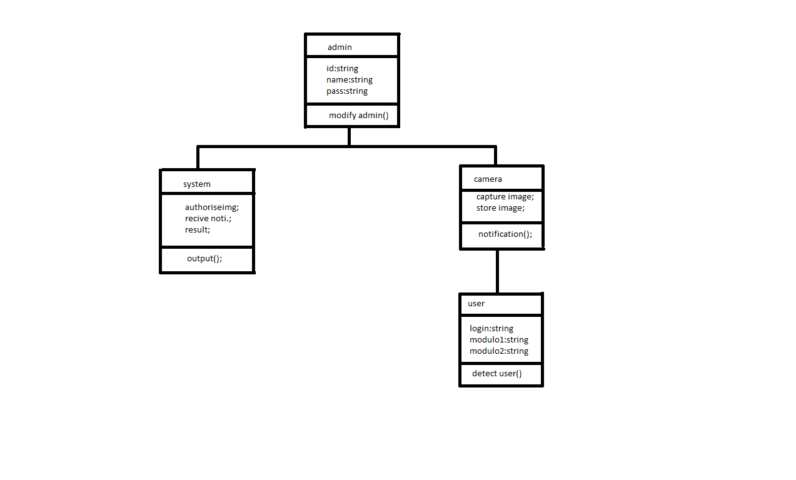

**CHAPTER-5**

**SYSTEM DESIGN**

Systems design is the process of defining the architecture, components, modules, interfaces, and data for a system to satisfy specified requirements. The System Design Description report provides summary or detailed information about a system design represented by a model. Systems design is therefore the process of defining and developing systems to satisfy specified requirements of the user.

* 1. **System procedural design**
     1. **Design Pseudo code or algorithm for method or operation**

Step 1: Face capturing

Step 2 Manage the database.

Step 3: Detect for face recognization.

Step 4: Checking the percentage of wearing mask.

Step 5: Receive Notification

Step 6: Authorization the notification and give output.

* + 1. **Flow Chart**

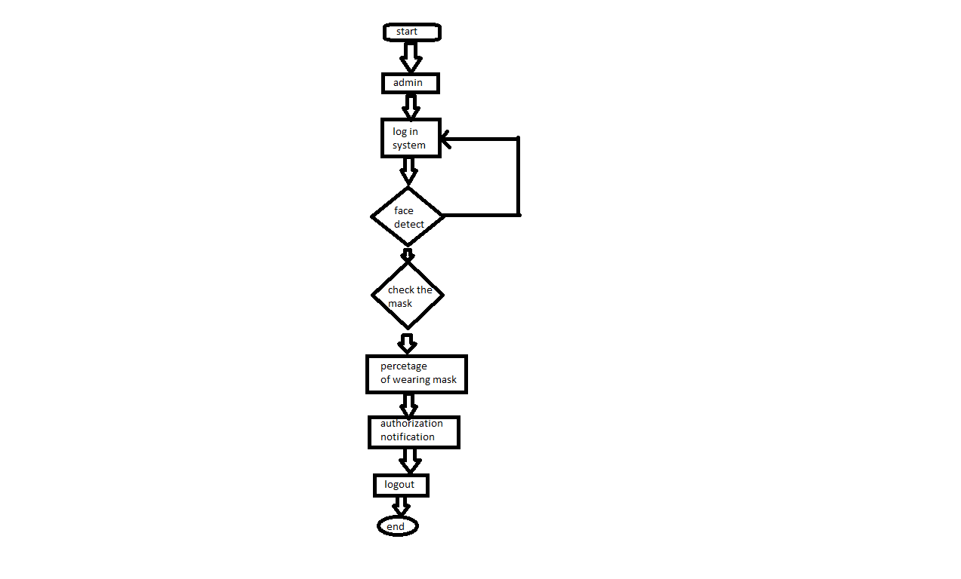

* 1. **Data Modeling:**
     1. **State chart diagram**

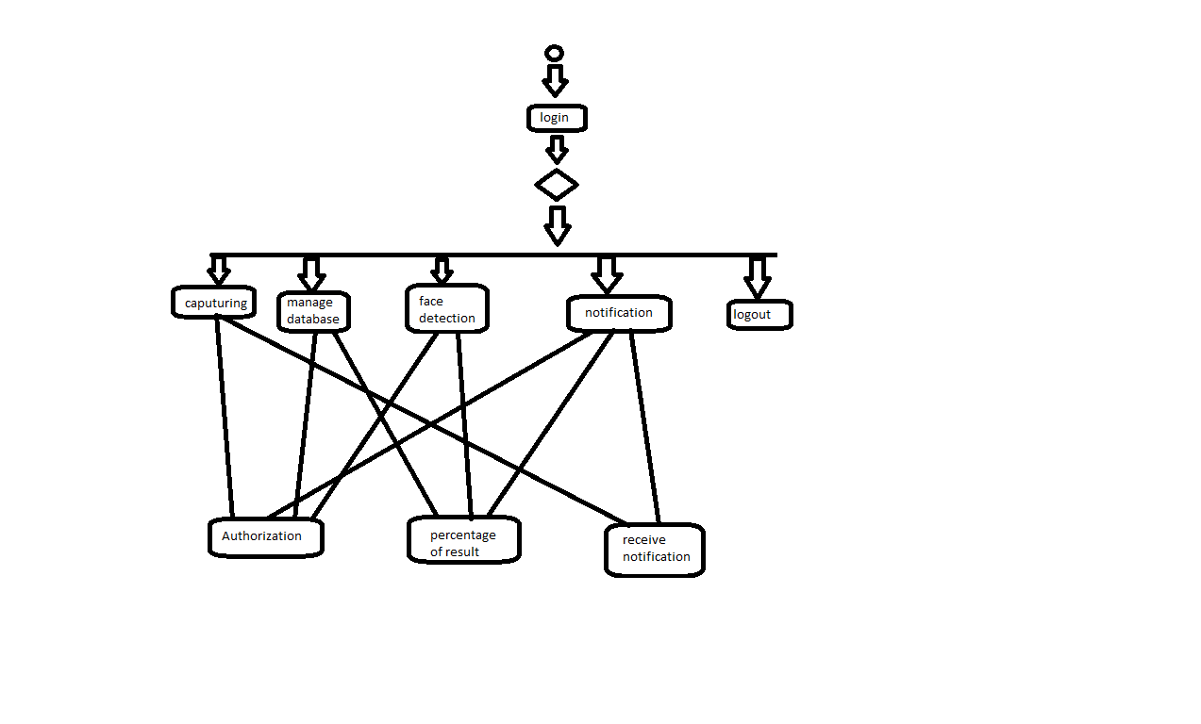

**CHAPTER 6**

**IMPLEMENTATION**

#### **Implementation planning & details:-**

* + - Implementation planning is the act of developing a tactical plan to complete a strategic initiative. Strategy is the overarching plan to move the organization, department, or project forward. Implementation is the act of putting the strategy into place utilizing resources within an organization or department. Execution is completing the tasks as part of the implementation plan to complete the strategic initiative through resources of the organized team.
    - Adding more to this, as we have defined in chapter 2 we are using web development to create an dynamic web application. We wanted to make our project in dynamic because it is the most growing technology nowadays.
    - So, our planning was very clean that first of all we will collect every detail related to our project from nearby aspects. And starting building our application on basis of our knowledge and based on the knowledge we can get from our guide.
    - And finally, when all information seems to be perfect from our perspective, we started developing the website. From basic design to hard databaseand user interaction activities..
    - We are facing many problems on the road of developing this website. But, with the help of team members and guide we are solving those problems and getting close to building application.

#### **Implementation Environment (Single vs Multi-user) :-**

* + - Each user is intended to be used by a different physical person. Each user has distinct application data and some unique perspective which makes them unique, as well as a user interface to explicitly switch between users. A user can run in the background when another user is active. the system manages shutting down users to conserve resources when appropriate.
    - A layout defines the structure for a user interface in your app, such as in activity. All elements in the layout are built using a hierarchy of View and View Group objects. A View usually draws something the user can see and interact with. Whereas a View Group is an invisible container that defines the layout structure for View and other ViewGroup objects..

#### 

#### **Program/Modules Specification**:-

* + - A module is a collection of source files and build settings that allow you to divide your project into discrete units of functionality. Our project can have one or many modules and one module may use another module as a dependency. Each module can be independently built, tested, and debugged.
    - Additional modules are often useful when creating code libraries within your own project or when you want to create different sets of code and resources for different device types, such as phones and wearables, but keep all the files scoped within the same project and share some code.
    - Within each module, files are shown in the following groups.

.

* + - **PYTHON: -** Contains the Python source code files, separated by package names, including index test code.
    - **Postgres :**- It is a open source relational data base management system emphasizing extensibility and SQL compliance.

#### **Security Features:-**

* + - A robust securitymodel is essential to enable a vigorous ecosystem of applications and devices built on and around the Android platform and supported by cloud services. As a result, through its entire development lifecycle.
    - We should minimize the number of permissions that your app requests. Restricting access to sensitive permissions reduces the risk of inadvertently misusing those permissions, improves user adoption, and makes your app less vulnerable for attackers.
    - Generally, you should strive to define as few permissions as possible while satisfying your security requirements.
    - By following standard coding style and guidelines, we can build a better website
    - If you follow standard coding style in android, it will be easier for you and also for others to understand your code easily.
    - Coding Style for Contributors**: -**From here you can learn the coding style that you should follow while contributing to python source code.
    - Project Guidelines**: -** here you will get to know about file naming, parameter ordering in methods, etc

CHAPTER 7

TESTING

#### **Testing Plan:-**

* + - Web application testing is a process by which application software developed for handheld website is tested for its functionality, usability and consistency. Website application testing can be an automated or manual type of testing.
    - A Test Plan is a document which describes a scope of testing, test strategy, objectives, effort, schedule and resources required. Its main purpose is to guide the whole testing process and used mostly by Project Managers or Tests Engineers.

#### **Testing Strategy:-**

* + - Test strategy :- A test strategy is an outline that describes the testing approach of the software development cycle. It is created to inform project managers, testers, and developers about some key issues of the testing process.
    - A Test Strategy document is a high-level document and normally developed by project manager. This document defines “Software Testing Approach” to achieve testing objectives. ... Some companies include the “Test Approach” or “Strategy” inside the Test Plan, which is fine and it is usually the case for small projects.

#### **Testing Methods:-**

* + - These testing methods are usually conducted in order and include : Unit testing. Integration testing. System testing
    - Unit tests often mirror the structure of the code under test. For example, a unit test project would be created for each code project in the product. The test project can be in the same solution as the production code, or it can be in a separate solution. You can have multiple unit test projects in a solution.
    - Integration testing is a component of Extreme Programming (XP), a pragmatic method of software development that takes a meticulous approach to building a product by means of continual testing and revision. There are two major ways of carrying out an integration test, called the bottom-up method and the top-down method
    - System Testing (ST) is a black box testing technique performed to evaluate the

complete system the system's compliance against specified requirements. In System testing, the functionalities of the system are tested from an end-to-end perspective It

includes both functional and Non-Functional testing.

#### **Test Cases(Purpose, Required Output, Expected Result):-**

* + - A Test Case is defined as a set of actions executed to verify a particular feature or functionality of the software application. A test case is an indispensable component of the Software Testing Lifecycle that helps validate the AUT (Application Under Test).
    - A user guide or user's guide, also commonly known as a manual, is a technical communication document intended to give assistance to people using a particular system.User guides are most commonly associated with electronic goods, computer hardware and software, although they can be written for any product

**8. Screen Shots of the Codes**

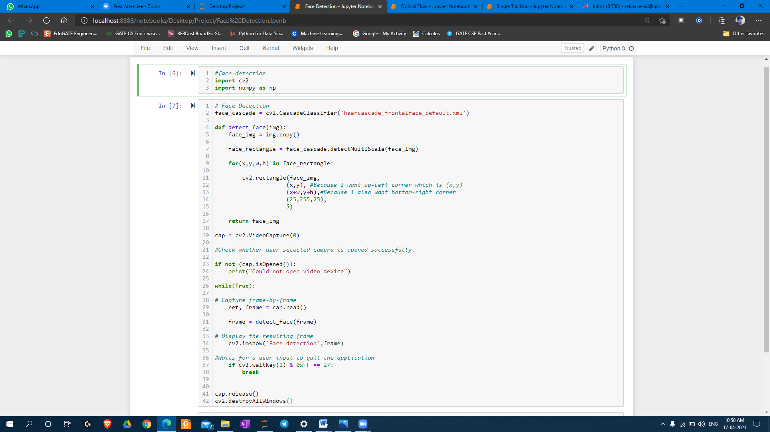**Face Detection Code**

**Face Detection Output:**

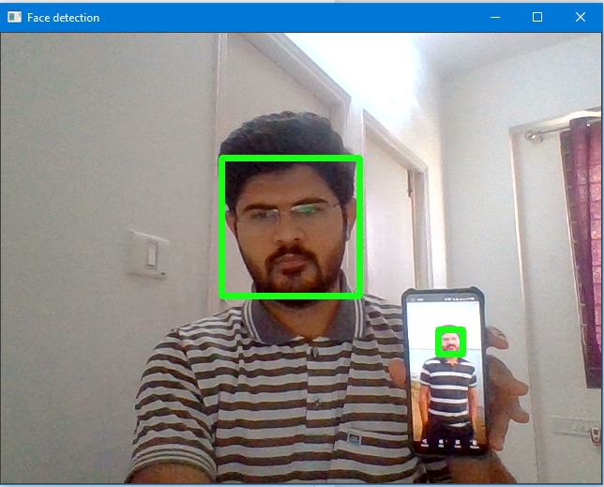

**Optical Flow:**

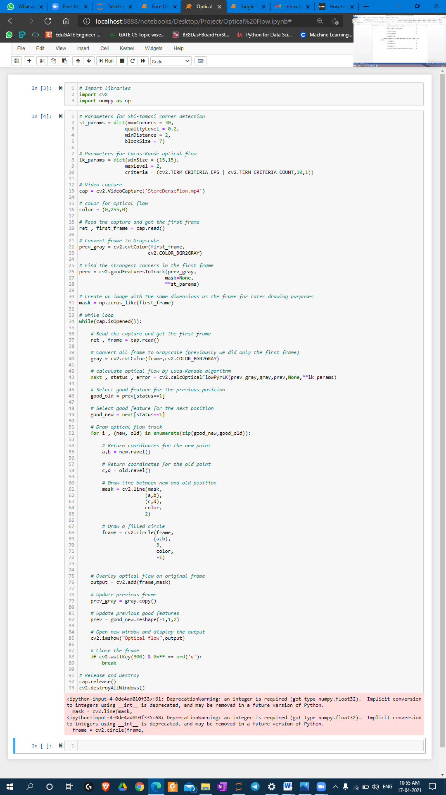

**Optical Flow Output:**

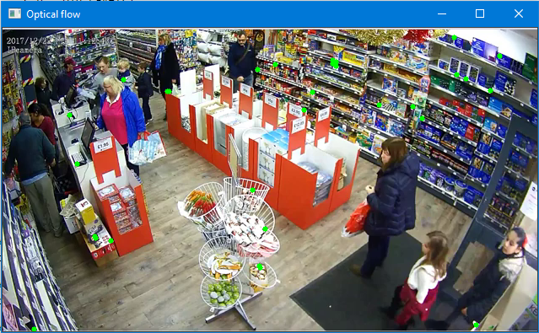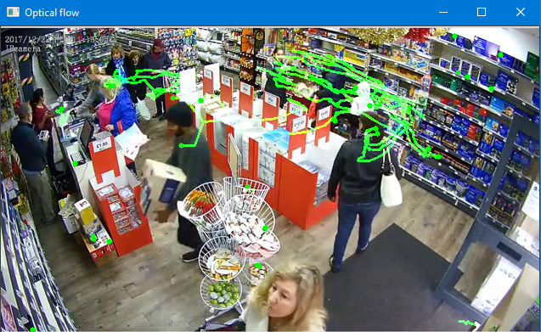

**Signal Tracking Code:**

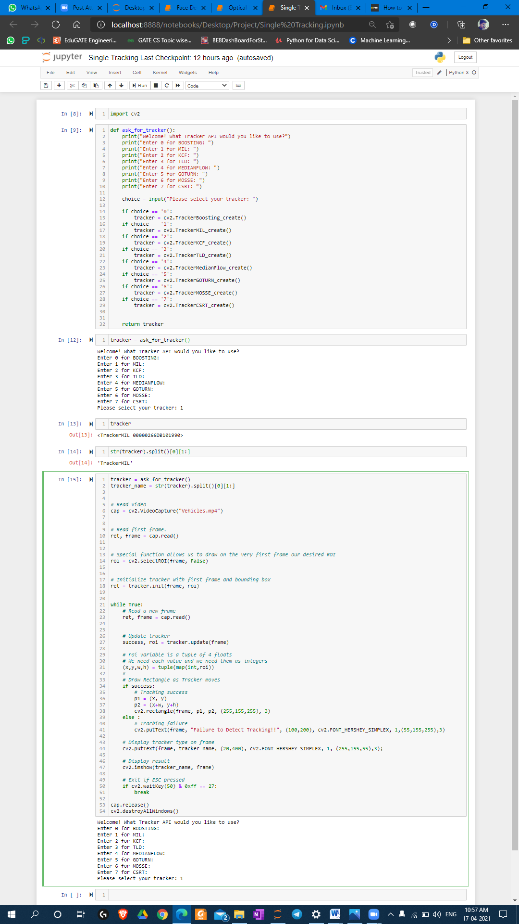

**Signal Tracking Output:**

